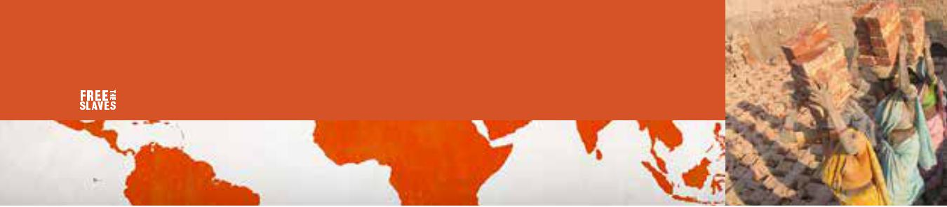
TRAFFICKING AND SLAVERY FACT SHEET

TENS OF MILLIONS OF PEOPLE ARE IN SLAVERY TODAY

RESEARCHERS ESTIMATE 21 MILLION ARE ENSLAVED WORLDWIDE¹
Slavery generates $150 billion for traffickers each year²

78% of slavery victims today are in labor slavery¹

55% of slavery | 45% of
victims today | slavery victims
are women | today are men
and girls¹ | and boys¹
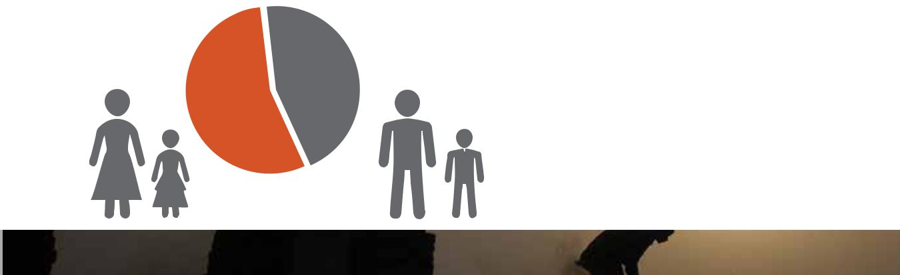
22% of slavery victims today are in sex slavery¹
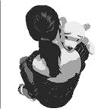

26%
of slaves today are children under age 18¹

SLAVERY is not legal anywhere but happens EVERYWHERE²
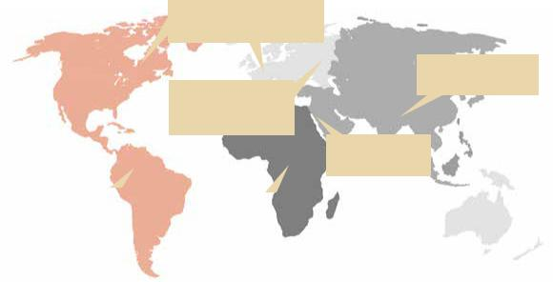
DEVELOPED ECONOMIES

1.5 million enslaved

ASIA & PACIFIC
11.7 million enslaved
CENTRAL &

SOUTHEAST EUROPE

1.6 million enslaved

MIDDLE EAST

600,000 enslaved

LATIN AMERICA &
AFRICA
CARIBBEAN
3.7 million enslaved
1.8 million enslaved

Sources:

- U.N. International Labor Organization Global Estimate of Forced Labor 2012 - www.ilo.org/washington/WCMS_182004/lang--en/index.htm

- U.N. International Labor Organization: Profits and Poverty, The Economics of Forced Labor, 2014 - http://www.ilo.org/wcmsp5/groups/public/---

ed_norm/---declaration/documents/publication/wcms_243391.pdf

FREE THE SLAVES | 1320 19th Street NW, Suite 600, Washington, DC 20036 USA | Tel.202.775.7480 www.freetheslaves.net | info@freetheslaves.net | facebook.com/freetheslaves | Twitter: @freetheslaves

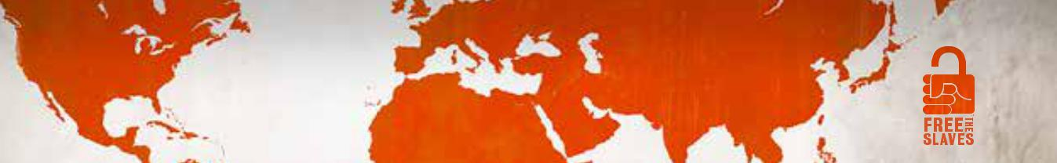
Freeing Slaves Ending Slavery

MISSION & HISTORY: Free the Slaves liberates slaves around the world and changes the conditions that allow slavery to persist. Founded in 2000, we are widely regarded as pioneers and leaders in the modern abolitionist movement. Our history is one of groundbreaking research, advocacy to change government policies and business practices, compelling documentary films to spread awareness that slavery still exists, and innovative front-line field programs that free slaves and demonstrate the feasibility of eradicating slavery.

WHERE WE WORK: Free the Slaves operates field programs in some of the world’s worst trafficking hot spots. More than 75 percent of our funds goes directly to programs. We rigorously and systematically assess our work to ensure accountability and to continuously improve our programs.

STRATEGY: Slavery is the result of vulnerability: the poor, the uneducated and the marginalized are exploited and coerced to work without pay. Under threat of violence, they cannot walk away. Our strategy is to reduce people’s vulnerability.
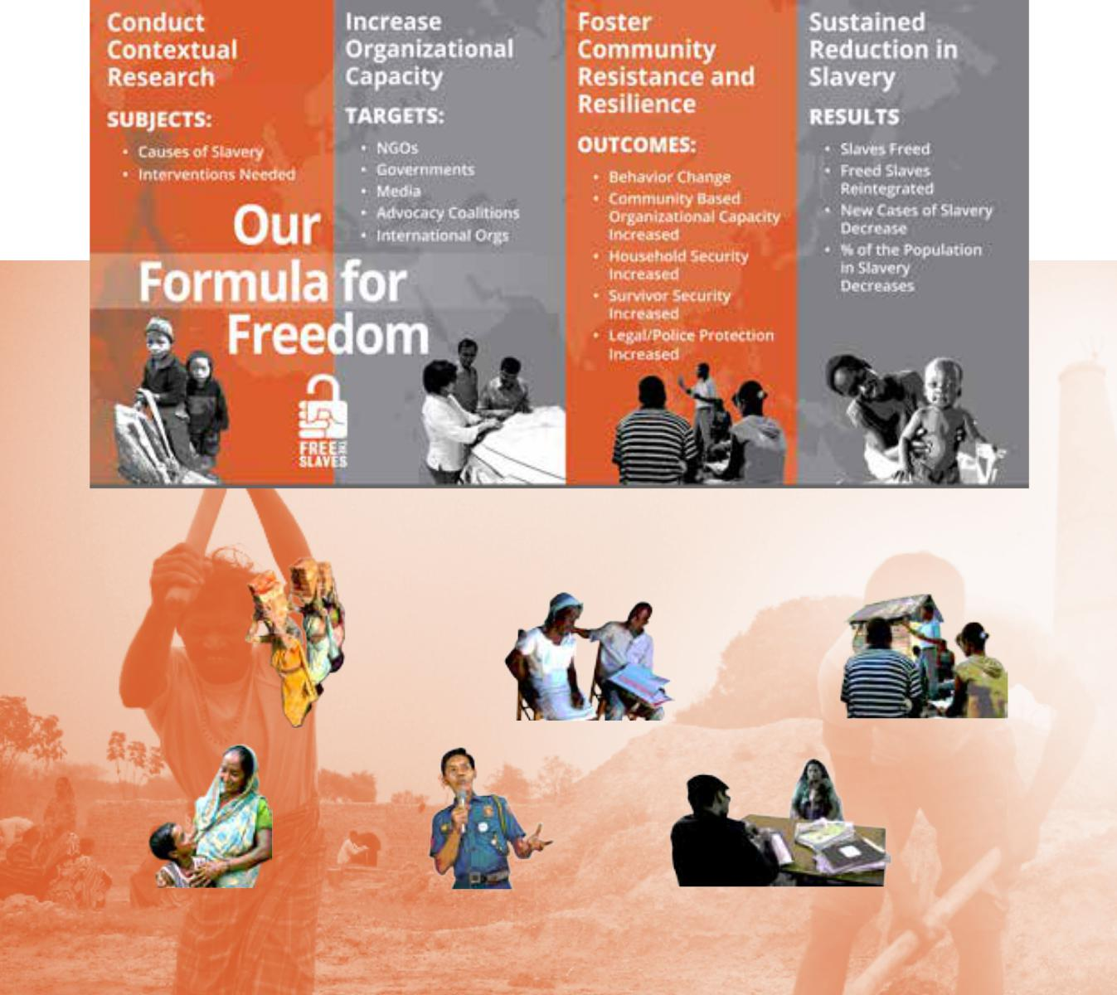

Empowering Communities For Freedom 2015 By the Numbers

1,106 | 4,051 | 327,135
People Freed | Slaves or | People Reached
from Slavery | Survivors | Through Awareness
 | Receiving FTS/ | Raising & Rights
 | Partner Services | Education

1,709 | 1,405 | 74
Communities | Government | Traffickers and
Receiving | Officials | Slaveholders
Support | Trained | Arrested

FREE THE SLAVES | 1320 19th Street NW, Suite 600, Washington, DC 20036 USA | Tel.202.775.7480 www.freetheslaves.net | info@freetheslaves.net | facebook.com/freetheslaves | Twitter: @freetheslaves

